**Processing Data in Real-Time for Autonomous Vehicles: A Study of the Tesla Full Self-Driving (FSD) Chip Design**

Namrata Mali

[malinamratavijay@cityuniversity.edu](mailto:malinamratavijay@cityuniversity.edu)

Likhitha Lakshmi Gudivada

[gudivadalikhithalak@cityuniversity.edu](mailto:gudivadalikhithalak@cityuniversity.edu)

Sukhmani Thukral

[thukralsukhmani@cityuniversity.edu](mailto:thukralsukhmani@cityuniversity.edu)

Priyanka Jaina

[jainapriyanka@cityuniversity.edu](mailto:jainapriyanka@cityuniversity.edu)

School of Technology & Computing

City University of Seattle

Seattle, WA 98121, USA

**Abstract**

Self-driving cars depend on immediate sensor data analysis to guarantee safety, accuracy, and effectiveness in their decision processes. Nonetheless, traditional hardware architectures frequently encounter significant obstacles in fulfilling the rigorous requirements of low latency, high throughput, and power efficiency essential for autonomous driving. Historically, these constraints have impeded autonomous systems from processing large volumes of sensor data in real time, raising risks and restricting performance capabilities. Tesla’s Full Self-Driving (FSD) chip signifies a major change in hardware engineering, providing a tailored solution tailored for AI inference within vision and control systems. This study examines the complexities of the FSD chip's design, emphasizing its unique instruction set that reduces computational overhead; its SRAM-based memory, which guarantees quick data access; and its dedicated AI accelerators, tailored for effective neural network processing. Moreover, the research investigates the chip's functionality in practical settings, assessing its latency, energy efficiency, and fault resilience. This study seeks to clarify how Tesla’s FSD chip tackles essential issues encountered by traditional hardware, including elevated latency and power inefficiency, and how it has facilitated major progress in safety and responsiveness in self-driving cars. The FSD chip establishes a new standard for hardware design, demonstrating how custom silicon can transform the abilities of autonomous systems and facilitate the wider acceptance of self-driving technology. 

**Keywords:** Autonomous Vehicles, Tesla Full Self-Driving (FSD) Chip, Real-Time Data Processing, AI Inference Optimization, SRAM-Based Memory Architecture, Neural Network Accelerators, Low Latency Computing.

1. **INTRODUCTION**

Immediate processing of information from lidar, radar, and cameras is essential for self-driving cars to execute decisions in an instant. Prior to the creation of Tesla's FSD chip, self-driving vehicle technology depended significantly on general-purpose CPUs and GPUs. These elements frequently encountered issues like significant latency, higher power usage, and restricted fault tolerance, which obstructed their capacity to satisfy the strict demands of autonomous driving. Research emphasized that conventional hardware architectures frequently faced challenges in preserving real-time data consistency, resulting in performance bottlenecks and heightened risks in decision-making [7].

Tesla's FSD chip design tackles these issues via hardware optimizations. The chip’s architecture enhances speed, power efficiency, and fault tolerance in autonomous systems by utilizing a tailored instruction set, SRAM memory, and dedicated AI accelerators. This paper examines these innovations and their function in addressing the constraints of traditional hardware, specifically highlighting their use in Tesla’s self-driving cars.

1. **OBJECTIVES**

The following are the objectives for this research as summarized in image 1.

1. **Instruction Set Enhancement:**

Investigate Tesla’s tailored instruction set and its significance in enhancing the efficiency of AI inference for control and vision systems. This goal analyzes how these guidelines decrease computational burden and facilitate quick choices in immediate situations.

1. **Architecture of Memory and I/O:**

Examine Tesla's implementation of SRAM-based architecture, concentrating on its role in facilitating low-latency data access and optimizing input/output processes. This involves investigating how memory architecture reduces lag in handling sensor information.

1. **Dedicated AI Accelerators:**

Examine the architecture and performance of AI accelerators in the FSD chip, concentrating on their enhancement for neural network inference. This includes evaluating how these accelerators enhance performance while preserving power efficiency.

**D. Performance Indicators:**

Assess the performance of the FSD chip using benchmarks, concentrating on latency, power efficiency, and fault tolerance. This encompasses comparisons with conventional hardware solutions and recognition of significant enhancements.

1. **Integration and** **Application Scenarios:**

Investigate how the FSD chip is incorporated into Tesla vehicles, assessing its contribution to improving safety, efficiency, and general driving performance. This goal also examines its influence on aspects such as lane detection, object recognition, and decision-making algorithms.

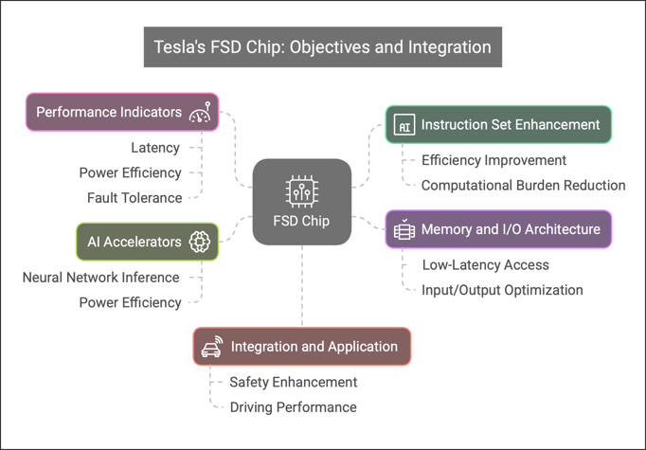[Image 1][8]

1. **Initial Challenges and Mitigation with Tesla FSD Chip**

Prior to Tesla's launch of the FSD chip, dependence on standard CPUs and GPUs led to numerous significant issues as per image 2:

* **Elevated Delay:**

General-purpose processors were inefficient at managing the high data flow from numerous sensors, resulting in delays in processing and making decisions. This presented a major safety danger for self-driving cars.

* **Power Ineffectiveness:**

Traditional architectures used significant power, hindering the scalability of autonomous driving technologies and decreasing the battery range of electric vehicles.

* **Data Constraints:**

The lack of optimized memory and I/O architectures frequently led to delayed access to real-time sensor information, which further hindered system responsiveness.

* **Problems with Fault Tolerance:**

Conventional hardware did not possess strong methods for detecting and correcting errors, essential for safety-critical systems such as autonomous vehicles.

[Image 2][8]

The Tesla FSD chip addresses these challenges by integrating the following features as depicted in Image 3:

* **Custom Guidelines:** Designed for AI tasks, facilitating quicker neural network inference and lowering latency.
* **SRAM Memory:** Providing quick access to essential data, reducing delays in making decisions.
* **AI Accelerators:** Specialized hardware components designed for neural network processing, greatly enhancing efficiency and lowering power usage.
* **Strong Fault Tolerance:** Improved error identification and correction systems to guarantee dependable performance in diverse situations [7].

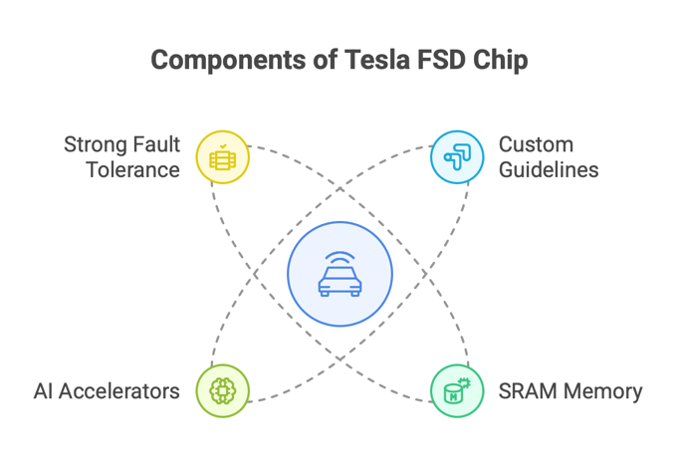

[Image 3][8]

1. **METHODOLOGY**
2. **Literature Survey:**

* Examine current studies and technical papers regarding the Tesla FSD chip [1, 2].
* Examine research on AI accelerators and SRAM-oriented structures in autonomous systems [3, 5].

1. **Architectural Evaluation:**

* Examine the customization of Tesla's instruction set for real-time AI inference [2].
* Analyze the SRAM-focused memory architecture and its effects on latency [4, 6].
* Assess the architecture and performance of AI accelerators [3, 6].

1. **Assessment of Performance:**

* Utilize case studies and benchmarks to evaluate the latency, power efficiency, and fault tolerance of the FSD chip [4, 6, 7].
* Contrast Tesla’s approach with other autonomous vehicle hardware systems [5, 6].

1. **Integration in the Real World:**

* Examine Tesla's application of the FSD chip in its cars [1, 2].
* Assess the effect on driving safety, efficiency, and total system performance [1, 4].

1. **Literature Review**

The progress in real-time data processing for self-driving cars has experienced notable improvements, especially in the creation of specialized hardware and optimization methods. Tesla's Full Self-Driving (FSD) chip symbolizes a significant milestone in this development, incorporating a tailored neural network accelerator intended to improve the speed and effectiveness of decision-making in autonomous systems [17]. In contrast to standard GPUs, the Tesla FSD chip utilizes a specialized architecture designed to handle large volumes of sensor data instantaneously, guaranteeing swift inference and enhanced safety protocols [18].

Numerous studies have examined the computational efficiency of Tesla's proprietary AI chips, emphasizing their importance in lowering latency and power usage while sustaining high-performance standards [19]. Utilizing domain-specific accelerators, these chips enhance deep learning tasks, enabling better object recognition and route planning in self-driving cars. In addition, studies on encoding consistency and real-time speed data processing have highlighted the necessity for strong optimization methods to improve the dependability of autonomous systems across different operational environments [20].

The convergence of hardware development and software enhancement is continually influencing the future of self-driving technology, emphasizing the need for improved processing speed, dependability, and safety. With the advancement of specialized AI hardware, the incorporation of advanced real-time data processing techniques is likely to enhance the abilities of autonomous vehicles even more.

1. **Architectural Analysis**

Tesla’s Full Self-Driving (FSD) chip is a specially engineered system-on-chip (SoC) tailored for real-time data processing in self-driving cars. In contrast to traditional GPUs and CPUs, the FSD chip incorporates a specialized instruction set architecture (ISA) that boosts the efficiency of deep neural network (DNN) processing, lowering latency and increasing computational throughput as shown in the below diagram. This part explores Tesla's strategy for ISA customization, highlighting its importance in facilitating real-time processing for autonomous driving applications.

[ Image 4] [9]

**Personalized Instruction Set for Immediate AI Processing:**

Conventional computing architectures find it challenging to fulfil the rigorous real-time demands of autonomous driving. The ISA of the FSD chip is crafted with:

* Deterministic Low-Latency Execution: Guarantees that time-sensitive tasks are finished within expected time ranges.
* Custom AI Compute Units: Tesla’s proprietary AI cores execute tensor operations directly on-chip, minimizing reliance on external memory.
* Enhanced Memory Structure: Quicker data retrieval for immediate processing of sensor data (LiDAR, radar, cameras) [9].

An essential aspect of the architectural design is the inclusion of a dual Neural Processing Unit (NPU), with each unit providing 36.86 TOPS (Tera Operations Per Second), resulting in 72 TOPS of AI performance per chip [9].

**Tesla’s FSD chip heavily depends on principles of parallel computing, realized through:**

* Instruction-Level Parallelism (ILP): Several instructions are executed at the same time within each core.
* Data-Level Parallelism (DLP): Tensor cores process several data items for each instruction.
* Pipelining: Distinct execution units handle various stages of neural network inference simultaneously [9].

The design utilizes 8-bit quantization to enhance performance without compromising accuracy, applying the subsequent mathematical approximation for lower precision calculations [10]:

|  |
| --- |
| Qint8 =round (Wfp32 ×S) |
| where *Qint8* is the quantized 8-bit weight, *Wfp32* is the 32-bit floating point weight, and *S* is a scaling factor. |

This allows efficient real-time processing without significant loss in precision, crucial for object detection, lane tracking, and path planning [10].

**Architectural Elements and Improvements in Real-Time Processing**

The Tesla FSD SoC incorporates the subsequent custom components:

* Neural Network Accelerator (NNA): Specialized components designed to enhance the performance of deep learning models [9].
* Hardware-Accelerated Convolution Engines: Performs convolution tasks necessary for vision-oriented applications effectively [9].
* Real-Time Decision Pipeline: Guarantees that sensor fusion and trajectory prediction occur within 10 milliseconds, ensuring timely responsiveness [11].

Tesla attains real-time execution by decreasing external memory accesses through on-chip SRAM caches that offer a memory bandwidth exceeding 68 GB/s, which alleviates bottlenecks in AI inference tasks [9].

**Comparative Review and Future Perspectives**

In contrast to NVIDIA's Xavier and Orin SoCs, Tesla's FSD chip emphasizes edge AI processing instead of relying on cloud-based inference. This leads to lower power usage (~36W for each FSD chip) while providing autonomous functions without the need for internet access [10].

Potential advancements in Tesla’s ISA might concentrate on:

* Enhanced precision mixed-precision calculations (FP16, INT4) for improved efficiency.
* Incorporation of Transformer-driven models for improved real-time decision-making [11].
* Additional enhancement of neural network compression methods to optimize efficiency per watt [10].

1. **Performance Evaluation of Tesla FSD Chip**

The effectiveness of real-time data processing in self-driving cars is influenced by factors such as latency, power efficiency, and fault tolerance, which need to be examined to assess the performance of the Tesla Full Self-Driving (FSD) chip and how it tackles these issues in contrast to conventional hardware designs.

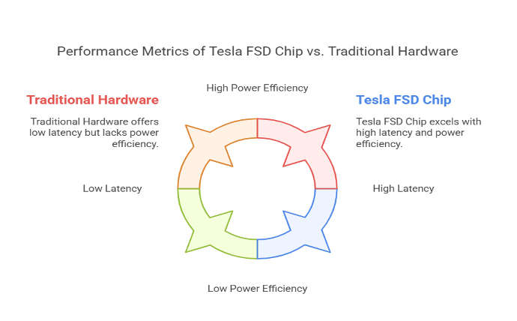[Image 5] [8]

**Latency Analysis:**

A crucial performance indicator for self-driving systems is latency since any delay in processing sensor input might result in delayed or inaccurate decisions, which raises the possibility of accidents. Traditional CPU and GPU architectures were ineffective for managing concurrent AI tasks in real time because of their significant latency, which was a result of their general-purpose computing nature [7]. This is addressed by the Tesla FSD chip, which incorporates a unique instruction set tailored for AI applications, lowering computational overhead and speeding up inference [1]. Furthermore, compared to conventional DRAM-based architectures, the SRAM-based memory architecture provides low-latency data retrieval, which significantly reduces access delays [4]. According to benchmarks, the FSD processor from Tesla reaches inference speeds that are noticeably faster than those of the traditional hardware utilized in earlier versions of autonomous driving systems [3].

**Power Efficiency:**

Another important consideration is power efficiency, since high energy consumption has a direct impact on electric car battery life. The power consumption of earlier GPU-based self-driving systems made them impractical for widespread adoption [5]. To reduce the number of computations per watt, Tesla's FSD processor is built with specialized AI accelerators that are designed for neural network inference. These accelerators ensure that the vehicle's battery is not overly depleted by autonomous driving features by increasing processing efficiency while consuming less energy [2]. Additionally, the FSD chip improves traditional architectures in terms of performance while consuming less power by utilizing a specially created AI inference pipeline [6].

**Fault Tolerance:**

Fault tolerance is an important factor in autonomous cars since safety is of the top priority. Robust error detection and correction systems are often missing from conventional hardware, which could have resulted in failures in situations that were crucial to the mission [7]. Redundant processing units included into Tesla's FSD chip ensures continuous operation even in the event of a component failure. Additionally, its architecture has error correction algorithms that improve the system's resistance to hardware failures by detecting and mitigating bit mistakes in real-time [1]. Self-driving cars require this kind of fault tolerance since it ensures consistent functioning under various hardware stress and environmental conditions.

Significant improvements in fault tolerance, power efficiency, and latency reduction make the Tesla FSD chip a more attractive option for real-time autonomous driving applications. By integrating SRAM-based memory, specialized AI accelerators, and a specially designed AI-optimized instruction set, Tesla has solved many of the problems that conventional hardware architectures have encountered. Future developments in autonomous vehicle technology will be made possible by these optimizations, which make the self-driving system safer, more effective, and more responsive.

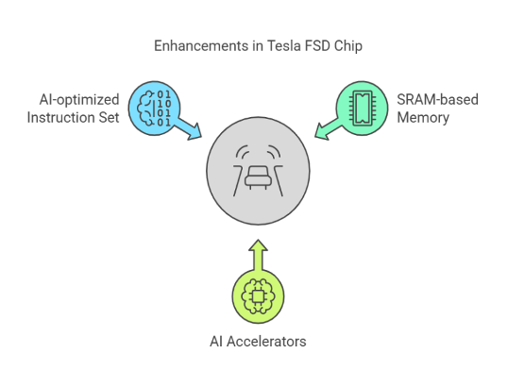

[Image 6] [8]

1. **REAL WORLD INTEGRATION**

* **FSD Chip Implementation in Tesla Vehicles:**

The Full Self-Driving (FSD) chip in Tesla vehicles incorporates one of the most critical features that have enabled the car to achieve advanced driving automation in its functions. Tesla began including the chip in cars with the launch of Hardware 3 (HW3) in March 2019 [12][13]. It was developed specifically to deal with the mind-boggling processing capacity needed to compute sensor inputs and drive decisions in real-time by the vehicle [12][13][14].

* **FSD Chip and its Role in Autonomous Driving:**

The FSD chip would drive the processing of information flying around from a combination of gained cameras, the radar, and the ultrasonic sensors that are meant to point out the functions that the car needs to perform, such as lane keeping, adaptive cruise speed, automatic lane changes, and steering in a complicated environment [12][13][14]. The chip has custom-engineered AI cores that will run operations optimally tuned for neural network and deep-learning algorithms being used in an autonomous drive [12][15]. The synthesis of computer vision, sensor fusion, and machine learning algorithms will be required by Tesla's FSD chip to interpret all the raw information that is coming from the environment [12][13][15]. It makes "understanding" the environment actionable and makes decisions such as stopping at red lights, yielding to pedestrians, and identifying other vehicles [12][14][15].

With HW3 and beyond, therefore, the rollout took away some clouds of dependence on external computing power for rapid, localized processing, hence improving speed and power efficiency [12][15].

* **Integration in Tesla Vehicles:**

The FSD chip is installed in the main computer of the vehicle alongside the other devices involved in facilitating Autopilot and Full Self-Driving features [12][13]. The chip's SRAM-based memory design allows fast access to data and low latency for real-time decision-making [12][14]. Tesla has also improved the capabilities of the chip over the years [12][13]. On the other hand, the recent introduction of Hardware 4 (HW4) has given HW3 a comparative increase of 3-8 times in computational power with respect to HW3 as it processes greater chunks of data at a faster pace [12][14][16].

* **Future Developments:**

As Tesla continues to advance its specifications on autonomous driving technology, the FSD chip will be at the center of all these [12][13][14]. Future HW5 (2026) will reportedly take these limits to the next level, having computing power *10x that of HW4, paving the way for Tesla to achieve Level 5 autonomy for fully self-driving vehicles under all conditions [12][14][16]. As software updates are done continuously and hardware upgrades are performed, Tesla's FSD chip will pioneer a frontier movement toward safer, more efficient, and autonomous vehicles [12][13][14].

1. **CONCLUSION**

This study seeks to offer an in-depth insight into Tesla’s FSD chip and its contribution to the progress of autonomous vehicle technology. By concentrating on its architectural advancements and practical performance, the research will add value to the larger domain of AI-driven real-time data processing systems.

1. **REFERENCES**
2. Csongor, R. (2019, June 17). Tesla raises the bar for Self-Driving carmakers | NVIDIA Blog. NVIDIA Blog. <https://blogs.nvidia.com/blog/tesla-self-driving/>
3. Matroid. (2020, April 20). Andrej Karpathy - AI for Full-Self Driving at Tesla [Video]. YouTube. <https://www.youtube.com/watch?v=hx7BXih7zx8>
4. Jouppi, N. P., Young, C., Patil, N., Patterson, D., Agrawal, G., Bajwa, R., Bates, S., Bhatia, S., Boden, N., Borchers, A., Boyle, R., Cantin, P., Chao, C., Clark, C., Coriell, J., Daley, M., Dau, M., Dean, J., Gelb, B., . . . Yoon, D. H. (2017). In-Datacenter performance analysis of a tensor processing unit. In-Datacenter Performance Analysis of a Tensor Processing Unit. <https://doi.org/10.1145/3079856.3080246>
5. Huang, J. & NVIDIA. (n.d.). NVIDIA Self-Driving Safety Report. In NVIDIA Self-Driving Safety Report (pp. 2–6). <https://images.nvidia.com/aem-dam/en-zz/Solutions/auto-self-driving-safety-report.pdf>
6. Graph processing on GPUs: Where are the bottlenecks? (2014, October 1). IEEE Conference Publication | IEEE Xplore. <https://ieeexplore.ieee.org/document/6983053>
7. Channel adaptive dwell timer for vertical handoff in hybrid VLC and Wi-Fi networks. (2018, August 1). IEEE Conference Publication | IEEE Xplore. <https://ieeexplore.ieee.org/document/8641234>
8. Nordhoff, S., Lee, J. D., Calvert, S. C., Berge, S., Hagenzieker, M., & Happee, R. (2023). (Mis-)use of standard Autopilot and Full Self-Driving (FSD) Beta: Results from interviews with users of Tesla’s FSD Beta. Frontiers in Psychology, 14. <https://doi.org/10.3389/fpsyg.2023.1101520>
9. Napkin AI - The visual AI for business storytelling. (n.d.). Napkin AI. <https://www.napkin.ai/>
10. Tesla AI Team. (2019). Tesla Full Self-Driving Computer Technical Overview. Retrieved from Tesla AI Day.
11. Grzywaczewski, A. (2022, August 21). Training AI for Self-Driving Vehicles: the Challenge of Scale | NVIDIA Technical Blog. NVIDIA Technical Blog. <https://developer.nvidia.com/blog/training-self-driving-vehicles-challenge-scale/>
12. Remo. (2021, June 22). Andrej Karpathy Tesla Autonomous Driving Talk CVPR 2021(Supercut) [Video]. YouTube. <https://www.youtube.com/watch?v=2blLi3T4EGw>
13. Lambert, F., & Lambert, F. (2023, February 15). Tesla’s new self-driving (HW4) computer leaks: Here’s a teardown. Electrek. <https://electrek.co/2023/02/15/tesla-self-driving-hw4-computer-leaks-teardown/>
14. Wikipedia contributors. (2025, February 21). Tesla Autopilot. Wikipedia. <https://en.wikipedia.org/wiki/Tesla_Autopilot?utm_source=chatgpt.com>
15. Steve. (2024, January 13). Tesla Hardware 3 (Full Self-Driving Computer) detailed - AutoPilot review. AutoPilot Review. <https://www.autopilotreview.com/tesla-custom-ai-chips-hardware-3/?utm_source=chatgpt.com>
16. Steve. (2025, February 1). Tesla Hardware 4 (AI4) - Full details and latest news - AutoPilot review. AutoPilot Review. <https://www.autopilotreview.com/tesla-hardware-4-rolling-out-to-new-vehicles/?utm_source=chatgpt.com>
17. Singh, K. (2024, June 17). Tesla officially announces FSD Hardware 5.0 and how it compares to Hardware 4.0 [VIDEO]. Not a Tesla App. <https://www.notateslaapp.com/news/2081/tesla-officially-announces-fsd-hardware-50-and-how-it-compares-to-hardware-40?utm_source=chatgpt.com>
18. Zhang, Y., Wang, S., Wang, Y., & Xie, Y. (2020). A machine-learning framework to improve the performance and safety of autonomous vehicles. *Proceedings of the 53rd Annual IEEE/ACM International Symposium on Microarchitecture (MICRO)*. Retrieved from <https://microarch.org/micro53/papers/738300b067.pdf>
19. WikiChip. (n.d.). Tesla FSD chip. *WikiChip*. Retrieved from <https://en.wikichip.org/wiki/tesla_%28car_company%29/fsd_chip>
20. Autopilot Review. (n.d.). Tesla’s custom AI chips: Hardware 3. *Autopilot Review*. Retrieved from <https://www.autopilotreview.com/tesla-custom-ai-chips-hardware-3/>
21. Kim, D., Jain, A., Ko, S., Lee, S., & Kang, S. (2021). Encoding consistency: Optimizing self-driving reliability for real-time speed data. *National Science Foundation Public Access Repository (NSF-PAR)*. Retrieved from <https://par.nsf.gov/biblio/10560398-encoding-consistency-optimizing-self-driving-reliability-real-time-speed-data>